1. Create a branch within jira

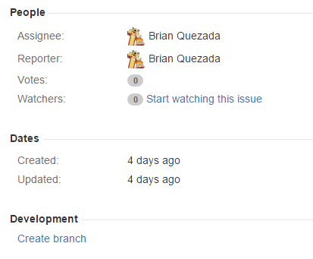

1. Make sure everything is correct

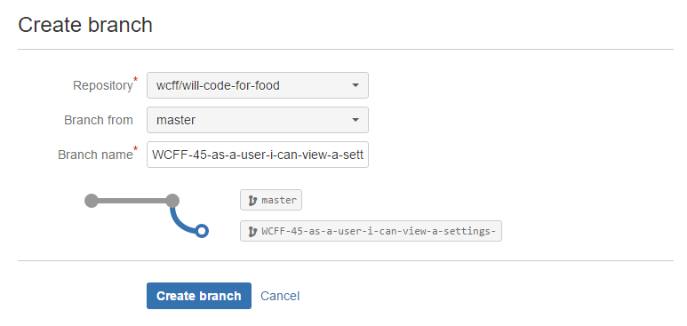

1. Pull (the blue arrow)



1. Go to Branches

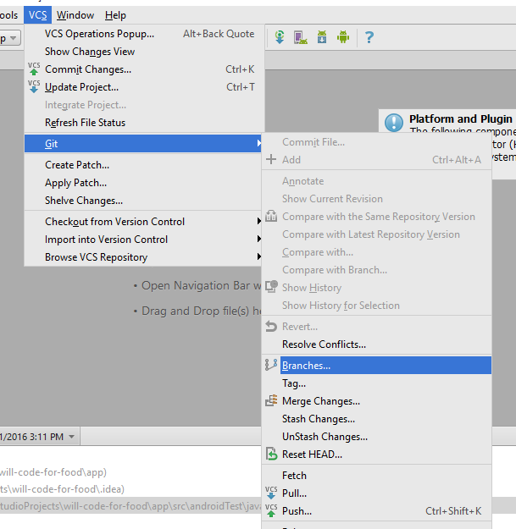

1. Checkout as new branch

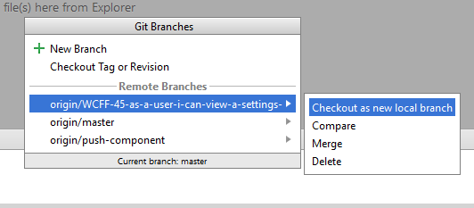

1. Do Work
2. Push Changes (the green arrow)



1. Go to bitbucket and click branches

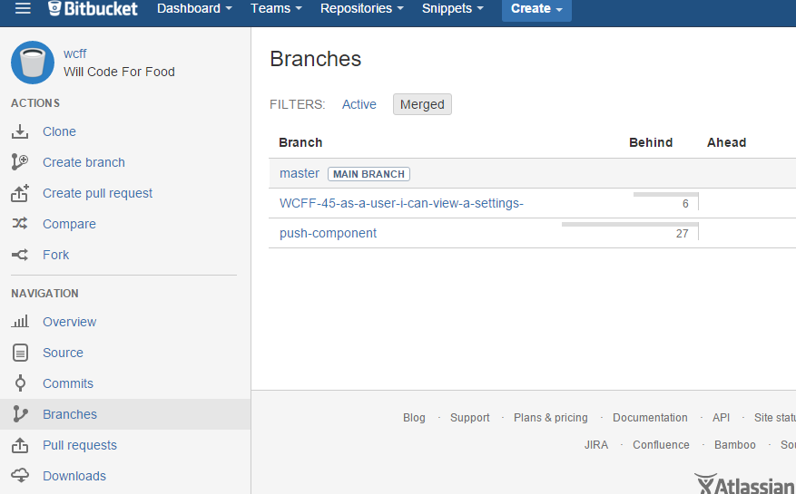

1. Hit “Create Pull Request”

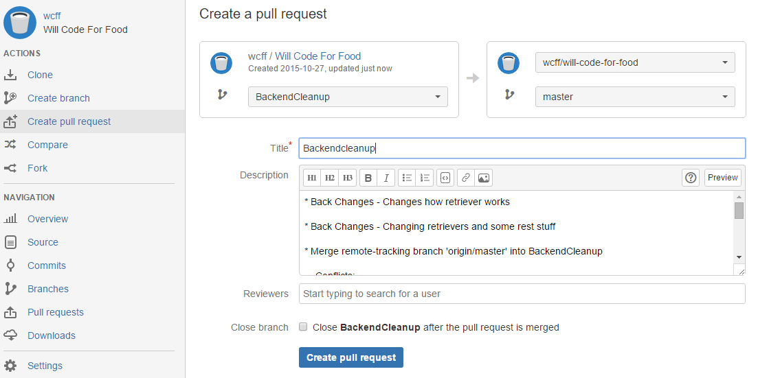

1. Select your branch in the dropdown in the first box. Generally it’s good to select “Close [branchname] after the pull request…”
2. Add a reviewer (or two if really important to review) and hit “Create pull request”

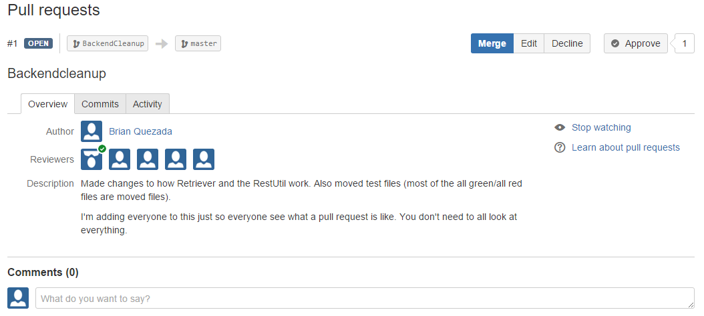

1. After people approve, go to pull requests, select your pull request
2. Hit Merge